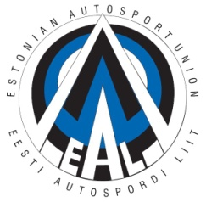
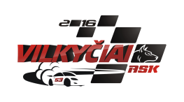
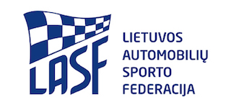
2nd STAGE OF BALTIC STATES RALLYCROSS CUP
ENTRY FORM
PLACE: Kebeliu village, Saugu eldership,
Silute COUNTRY: LITHUANIA DATE: 29. 07. 2018

ORGANIZER CLOSING DATE(S) FOR ENTRIES
Name: ASK „Vilkyčiai“ The entries must reach the organiser by:
Address: Minijos str. 27, Vilkyčiai, Lithuania 1. 28.07.2018 - 150 € Tel. +370 699 39290 135€ Entry fee + 15€ Paddock fee
E-mail: vilkyciai.ask@gmail.com
Website: www.askvilkyciai.lt

COMPETITOR
Name: .............................................................
Nationality: .....................................................
Address: ..........................................................
Tel.: .................................................................
Fax: .................................................................
E-mail: ............................................................
Division:
Touring
Super 1600
Open / Super Cars
Lada RX

Start number .........

Competition licence numbers:
Competitor:
Driver:
Signature
Competitor: ............................................
Driver: ....................................................
Date: ......................................................

DRIVER
Name: ...............................................................
Date of Birth: .....................................................
Nationality: ........................................................
Address: .............................................................
............................................................................
Tel: ....................................................................
Fax: ....................................................................
E-mail: ...............................................................

Marke ................................... Model...................... ................ cc............................... hp............................

Technical Passport Nº .....................................

Weight ........................... kg

We confirm that we have read and understood the provision of the International Sporting Code, The Autocross Technical Regulations and Autocross Sporting Regulations and we agree, on our own behalf and on behalf of everyone associated with our participation in the 2nd stage of Baltic States Rallycross Cup, to observe and be bound by them (as supplemented or amended). We declare that we have examined this Entry Form and that the information given is true, correct and complete. We understand that any change in the details given in this Entry Form must be reported to the Organiser.

