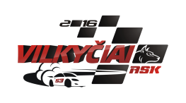
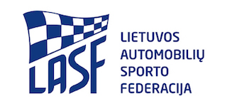

2018 EUROPEAN AUTOCROSS CHAMPIONSHIP
SUPPORT RACE „VILKYCIAI – 2018“ COMPETITION
ENTRY FORM
PLACE: Autocross track in Vilkyciai, Kebeliu village, Saugu eldership, Silute, Lithuania
DATE: 08-10/06/2018

ORGANIZER CLOSING DATE(S) FOR ENTRIES
Name: ASK „Vilkyčiai“ The entries must reach the organiser by:
Address: Minijos str. 27, Vilkyčiai, Lithuania 1. 25.05.2018 130 € +20 € (paddock fee)
Tel. +370 699 39290 2. 06.06.2018 170 € + 20 € (paddock fee)
E-mail: vilkyciai.ask@gmail.com Number of participants is limited (up to 20 participants)
Website: www.askvilkyciai.lt

COMPETITOR
Name: .............................................................
Nationality: .....................................................
Address: ..........................................................
Tel.: .................................................................
Fax: .................................................................
E-mail: ............................................................
Support race „Vilkyčiai – 2018“ competition National class

Start number .........

Signatures:
Competitor: ............................................
Driver: ....................................................
Date: ......................................................

DRIVER
Name: ...............................................................
Date of Birth: .....................................................
Nationality: ........................................................
Address: .............................................................
............................................................................
Licence number .................................................
Tel: ....................................................................
Fax: ....................................................................
E-mail: ...............................................................

Brand ................................... Model...................... ...........Technical Passport Nº .....................................

We confirm that we have read and understood the provision of the International Sporting Code, The Autocross Technical Regulations and Autocross Sporting Regulations and we agree, on our own behalf and on behalf of everyone associated with our participation in the 2018 FIA European Autocross Championship, to observe and be bound by them (as supplemented or amended). We declare that we have examined this Entry Form and that the information given is true, correct and complete. We understand that any change in the details given in this Entry Form must be reported to the Organiser.

