Saugos plano priedas Nr. 8.21.
________________________
(Renginio organizatorius)
__________________________________________
(Įmonės kodas, buveinės adresas, kiti duomenys)

PRANEŠIMAS APIE NELAIMINGĄ ATSITIKIMĄ

___________Nr._______
_________________
(Data)

_______________________________________________
(dokumento sudarymo vieta)

1. Nukentėjo ___________________________ , iš jų ___________________________žuvo, sunkiai sužaloti
_______________________________________ asmenys
2. Nukentėjo, žuvo_____________________________________________________________________
_____________________________________________________________________________________
_____________________________________________________________________________________
(vardas, pavardė)

3.Įvykio laikas _____________ m. _______________ ________ d. ________ val. ___________ min.
4.Įvykio vieta, jos adresas ir aplinkybės ___________________________________________________
_____________________________________________________________________________________________________________________________________________________________________________________________________________________________________________________________________________________________________________________________________________________________________________________________________________________________________________________________________________________________________________________________________________________________________________________________________________________________________________________________________________________________________________________________________________________________________________________________
5. Organizatorius _________________________________________________________________
6. Klubo vadovas _________________________________________________________________
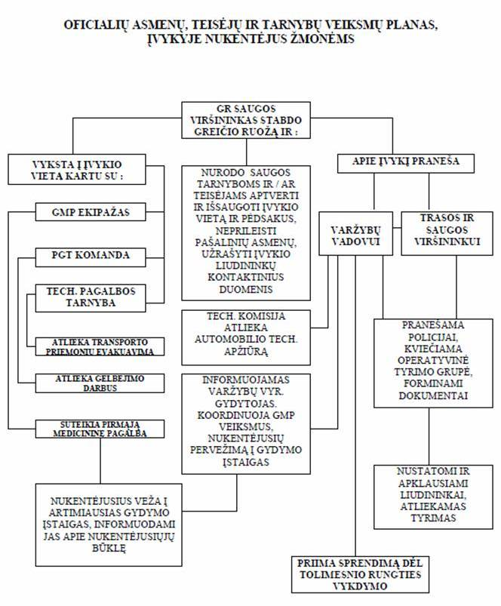
7. Varžybų vadovas _________________________________________________________________
8. Trasos ir saugumo viršininkas__________________________________________________________
9. Varžybų vyriausias gydytojas___________________________________________________________
10. Apie įvykį pranešė _____________________________________________________________________________________
_____________________________________________________________________________________
_____________________________________________________________________________________
11. Pranešimą priėmė _____________________________________________________________________________________
_____________________________________________________________________________________
12. Nelaimingą atsitikimą tiria ____________________________________________________________________________________
____________________________________________________________________________________

Pranešimą surašė trasos saugumo viršininkas
_________________________________________________

