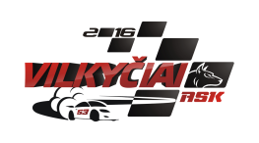
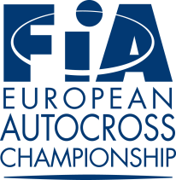

FIA European Autocross Championship
ENTRY FORM
PLACE: Kebeliu village, Saugu eldership,
Silute COUNTRY: LITHUANIA DATE: 08-10. 06. 2018

ORGANIZER CLOSING DATE(S) FOR ENTRIES
Name: ASK „Vilkyčiai“ The entries must reach the organiser by:
Address: Minijos str. 27, Vilkyčiai, Lithuania 1. 25.05.2018 220 €
Tel. +370 699 39290 2. 06.06.2018 275 €
E-mail: vilkyciai.ask@gmail.com 3. After 2nd closing date 440 €
Website: www.askvilkyciai.lt

COMPETITOR
Name: .............................................................
Nationality: .....................................................
Address: ..........................................................
Tel.: .................................................................
Fax: .................................................................
E-mail: ............................................................
Division:
Tourning Autocross
Buggy 1600
Super Buggy
Junior Buggy

Start number .........

Competition licence numbers:
Competitor:
Driver:
Signature
Competitor: ............................................
Driver: ....................................................
Date: ......................................................

DRIVER
Name: ...............................................................
Date of Birth: .....................................................
Nationality: ........................................................
Address: .............................................................
............................................................................
Tel: ....................................................................
Fax: ....................................................................
E-mail: ...............................................................

A.S.N. (Visa Stamp):

Marke ................................... Model...................... ................ cc............................... hp............................

FIA – Homologation Nº.............................. FIA Technical Passport Nº .....................................

Transponder nr .................................................

Turbo Yes 4WD Yes Weight ........................... kg
No No
We confirm that we have read and understood the provision of the International Sporting Code, The Autocross Technical Regulations and Autocross Sporting Regulations and we agree, on our own behalf and on behalf of everyone associated with our participation in the 2018 FIA European Autocross Championship, to observe and be bound by them (as supplemented or amended). We declare that we have examined this Entry Form and that the information given is true, correct and complete. We understand that any change in the details given in this Entry Form must be reported to the Organiser.

