PRIEDAS / APPENDIX 10
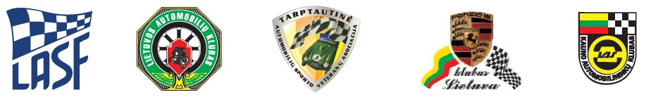
TARPTAUTINIS XLIV AUTORALIS „KAUNO RUDUO – 2017“
NUSIPELNIUSIEMS SPORTO MEISTRAMS KĄSTYČIUI IR ARVYDUI GIRDAUSKAMS ATMINTI
DALYVAUJANTIEMS 2017 m. LIETUVOS AUTOMOBILIŲ MINI RALIO ČEMPIONATO IV ETAPE
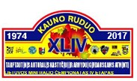
2017 09 22-23

PARENTAL CONSENT

I _ ________________________________________________________________________
personal code _______________________________ , tel. No._________________________
identified by ________________________________________________________________
living __________________________________________________________________and

personal code _______________________________ , tel. No._________________________
identified by ________________________________________________________________
living _____________________________________________________________ AGREE,
that my / son / daughter / ward _ ________________________________________________
would participate in Lithuanian Mini rally championship 4rd round („Kauno Ruduo-2017“)

I know that motosport can be life-threatening. I take full responsibility for my son / daugter
/ ward activities and/or the consequences for these actions, and no claims to the organizers,
LASF and to the official persons I will not have.

Name, Surname, signature

__________________________________________________________________________
Name, Surname, signature

N.B. „CONSENT“ is not valid without the parent / guardian personal identity document copies.

